**CREATING PPTP CLIENT WITH AUTO-CONNECT SCRIPT**

**Step 1: Update and Install.**

sudo apt-get update -y

sudo apt-get upgrade -y

sudo apt-get install -y pptp-linux

**Step 2: Creating a PPTP connection configuration.**

1. **ADDING SECRET ON MIKROTIK ROUTER:**

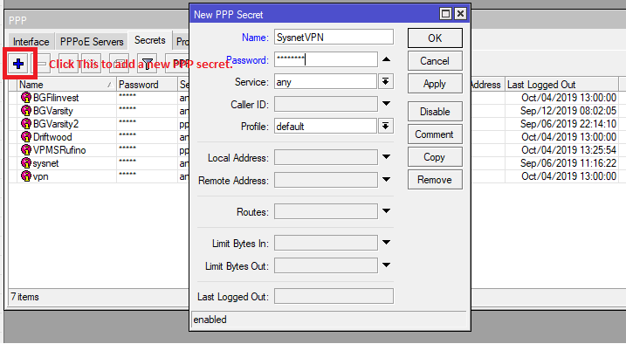

**Figure 1:** Adding a new PPP secret on MikroTik Router

1. **CREATING PPTP CONNECTION ON UBUNTU LINUX TERMINAL.**

sudo pptpsetup --create [vpn name] --server [Host] --username [PPP name] -- password [PPP password] --encrypt option –start

Note:

* The *“pptpsetup”* creates a configuration file that gets placed in **/etc/ppp/peers/** which is a superuser protected directory so you will need to run sudo to view its content.

Command on viewing the restricted file:

sudo ls -l /etc/ppp/peers/

sudo cat /etc/ppp/peers/[vpn name]

1. **CHECKING OF CONFIGURATION.**

Upon the successful application of creating a VPN on *“pptpsetup”* a good System Administrator should properly check its configuration on **/etc/ppp/chap-secrets**

Format should be:

# Secrets for authentication using CHAP

# client server secret IP addresses

[PPP name] [VPN name] “[PPP password]” *

Where:

* + **PPP name** is the MikroTik PPP name.
  + **VPN name** is the name of your PPTP connection.
  + **PPP password** is the MikroTik PPP password.
  + **\*** is the IP Address you assigned from the server.

Also upon a successful application of creating VPN through *“pptpsetup”* Linux system will creating a .txt file on **/etc/ppp/peers/[vpn name]** for which it will list down your host connection.

Format should be:

pty "pptp [Host] --nolaunchpppd"

name [PPP name]

remotename [vpn name]

ipparam [vpn name]

persist

refuse-pap

refuse-chap

refuse-mschap

maxfail 0

require-mppe-128

file /etc/ppp/options.pptp

mru 1500

mtu 1500

1. **CONNECTION/DISCONNECTION**

sudo pon [VPN name] updetach

* + - Connection of PPTP Client to PPTP Server.

sudo poff -a

* + - Disconnection of every active PPTP connection.

**Step 3: Linux Bootup Script.**

On Ubuntu 16.04, rc.local script is already implemented but on Ubuntu 18.04 you need to create your own rc.local file on **/etc.**

To create the file:

touch rc.local

* + - To create the file.

sudo nano rc.local

* + - To edit the file

sudo nano -B /etc/rc.local

* + - To create and edit the file using nano text editor to backup the rc.local file before making any changes to it.

On editing the file format should be like this:

#!/bin/bash or #!bin/sh

vpn="on"

if [ $vpn = on ]; then

printf "\nYour Description\n"

pon [VPN name] updetach

printf "Add Internet traffic route through ppp0\n"

sudo route add -net "0.0.0.0/0" dev "ppp0"

netstat -a | grep "/var/run/pptp/"

fi

exit 0

Make your rc.local file executable by:

sudo chmod +x rc.local

Run the file to test your script by:

./rc.local

This procedure will make the Operating System start the script upon booting or rebooting.

**Step 4: Linux Auto Reconnect Script.**

Upon testing and successful implementation of your scripts. Adding this will make you auto reconnect the PPTP connection once it was disconnected to the internet. On **/bin** create a file name vpnauto.sh by:

sudo nano vpnauto.sh

* + - To create and edit the file.

Format should be like this:

#!/bin/bash

date

sudo poff

sleep 10s

sudo pon [VPN name] updetach persist

exit

Make your vpnauto.sh file to be executable by:

sudo chmod +x vpnauto.sh

Run the executable vpnauto.sh file by:

./vpnauto.sh

**Step 5: Testing your Connection**

Since you have successfully implemented every command and script given above you must test it before putting it on production. Restart the device or remove its LAN cable to check if it will automatically reconnect.

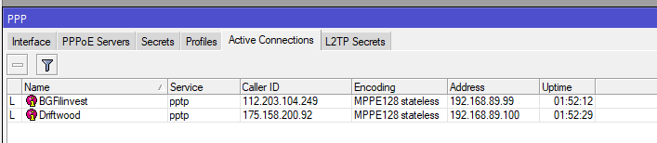

**Figure 2**: Successful Application of PPTP connection.